**ITT 450 – LAB1 KALI LINUX**

Name: Nurul Najihah Binti Mohd Nasir

Student Id: 2017342811

Class: CS2453A

1. ls - list information about files.

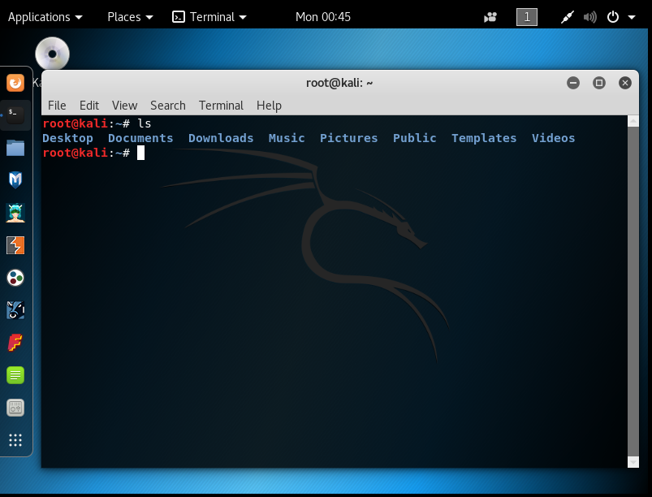

1. cd- change directory

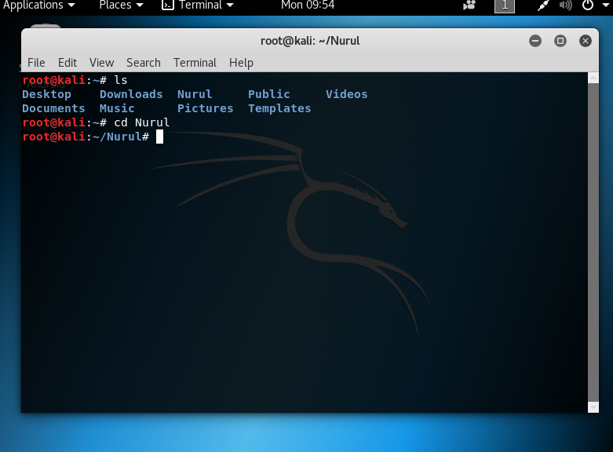

1. mv/ mkdir- create new directory or folder
2. rm /rmdir -to remove any folder or directory

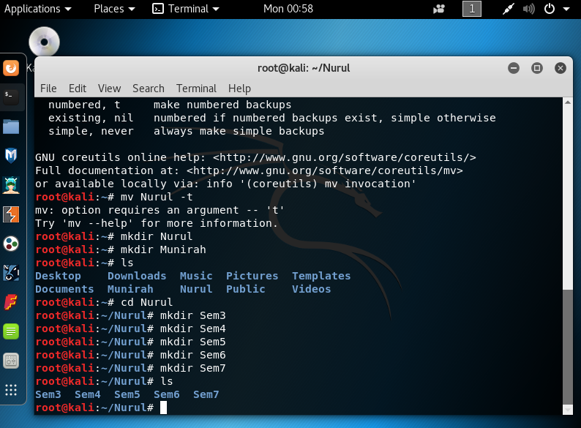

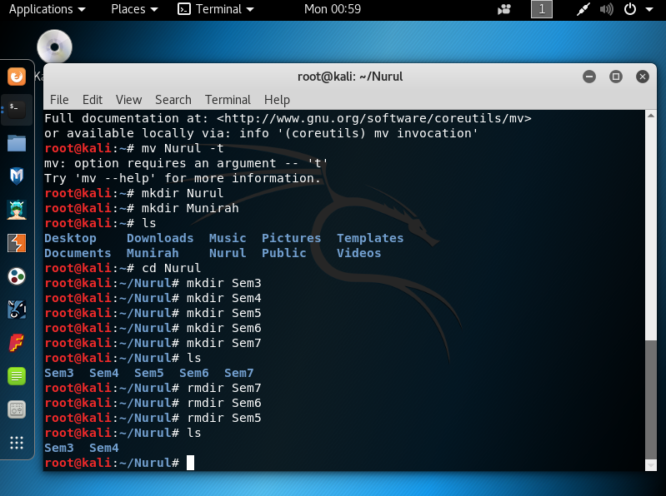

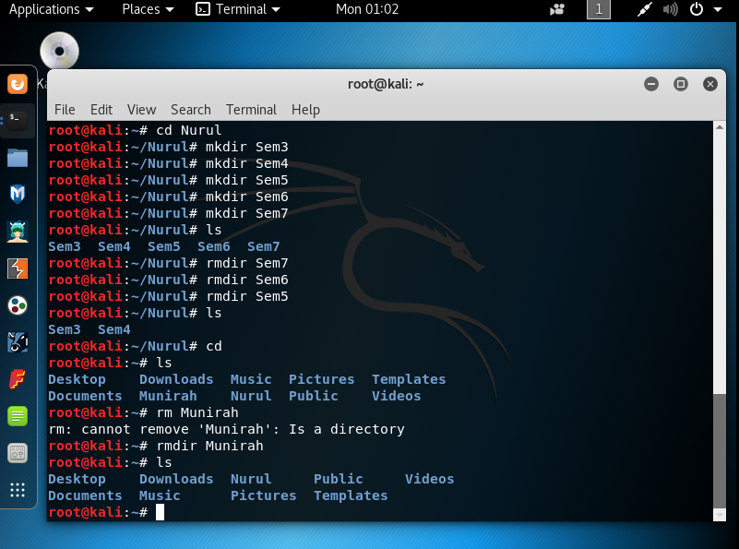

1. touch-change the file timestamps

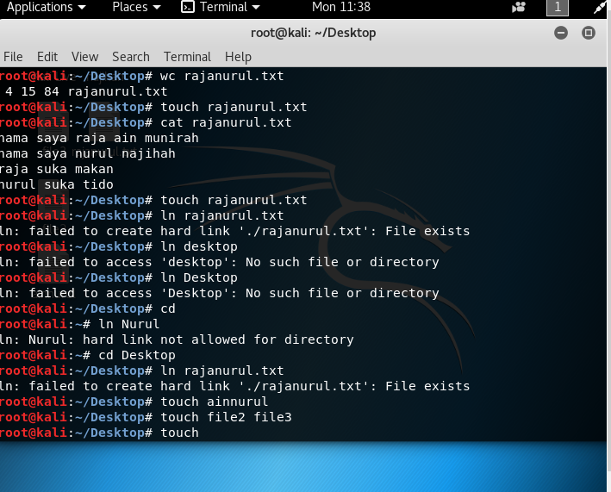

1. Cat - concatenate and print the content of files

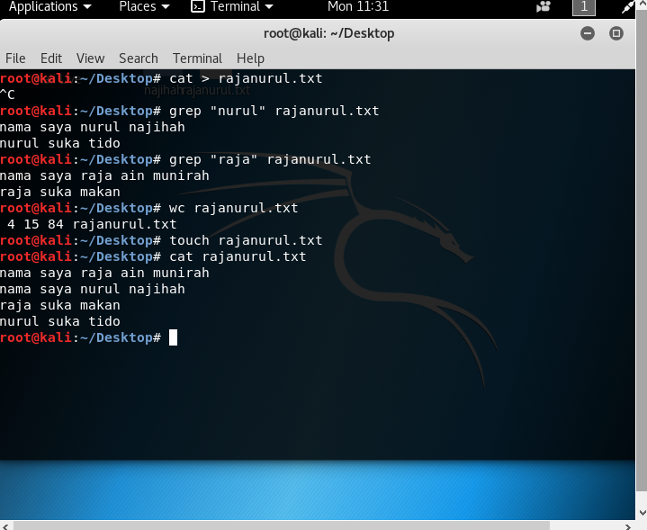

1. Pwd - Print working directory

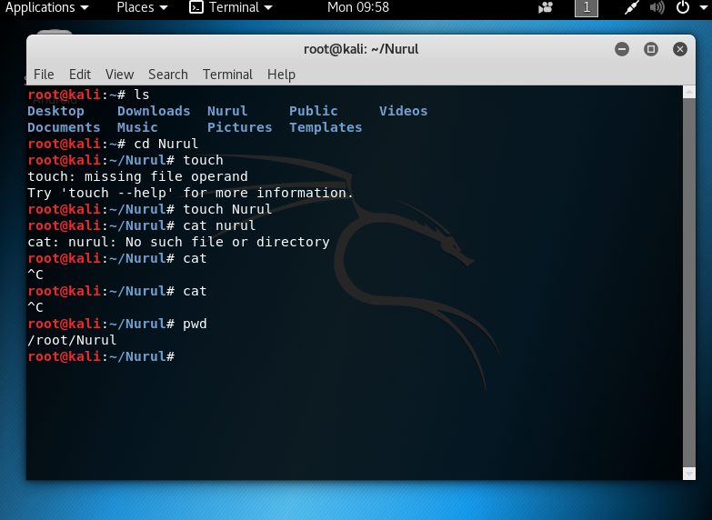

1. File -determine file type

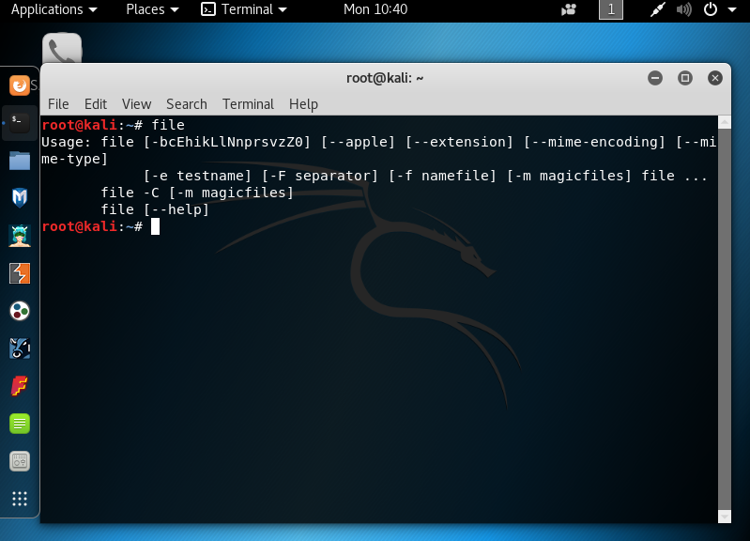

1. ln - create a symbolic link to a file
2. chmod/chown- chmod is to change access permission /chown is to change file owner and group

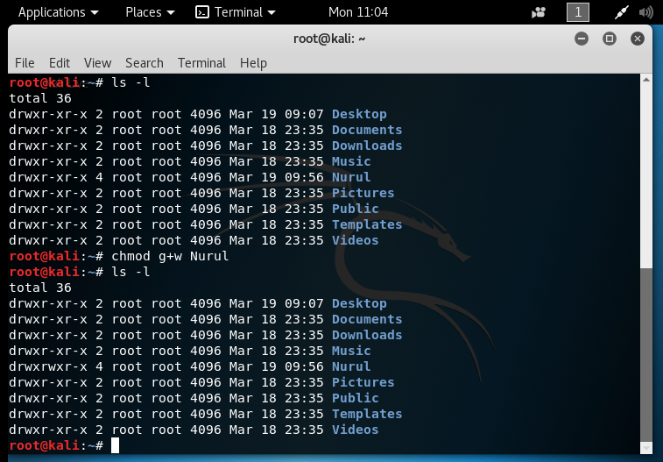

1. More/less - more and less is to display output one screen at a time

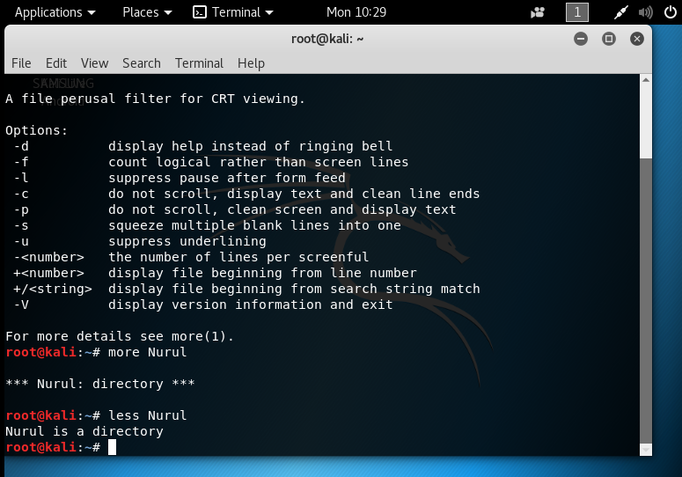

1. grep -search files for line that match a given pattern

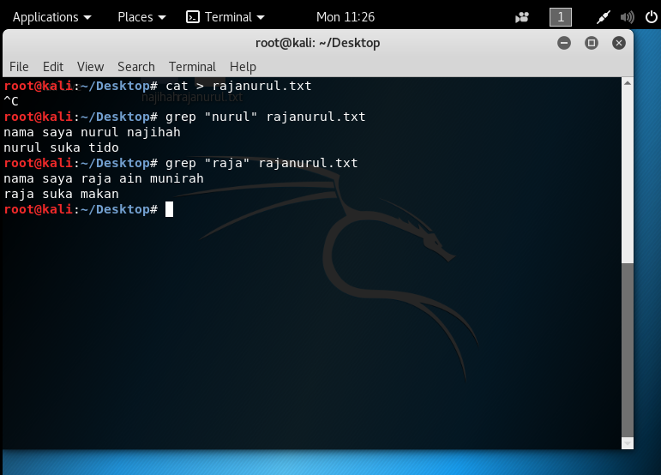

1. wc -print new line , word and byte counts for each file

4 – there is 4 line in rajanurul.txt

15 – there is 15 word in rajanurul.txt

84- there is 84 bytes in rajanurul.txt

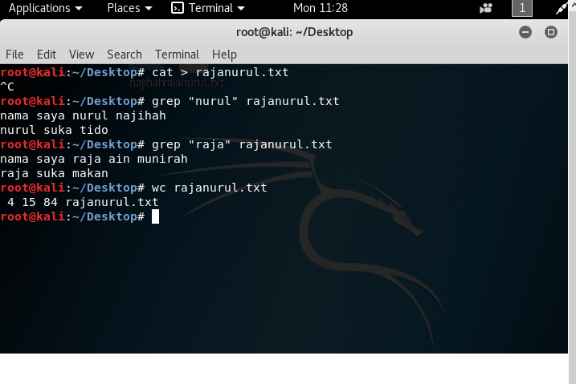

1. kill -stop a process from running/ terminate process

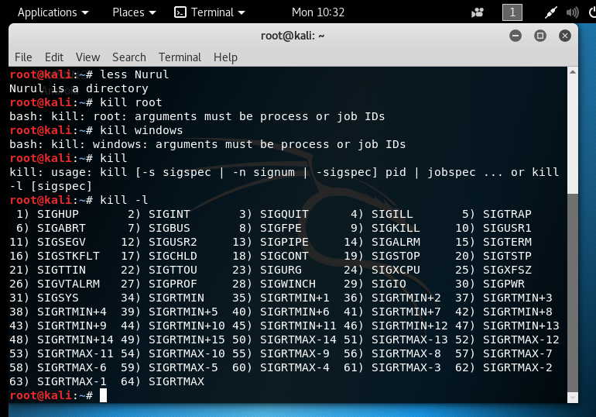

1. Ps - process status

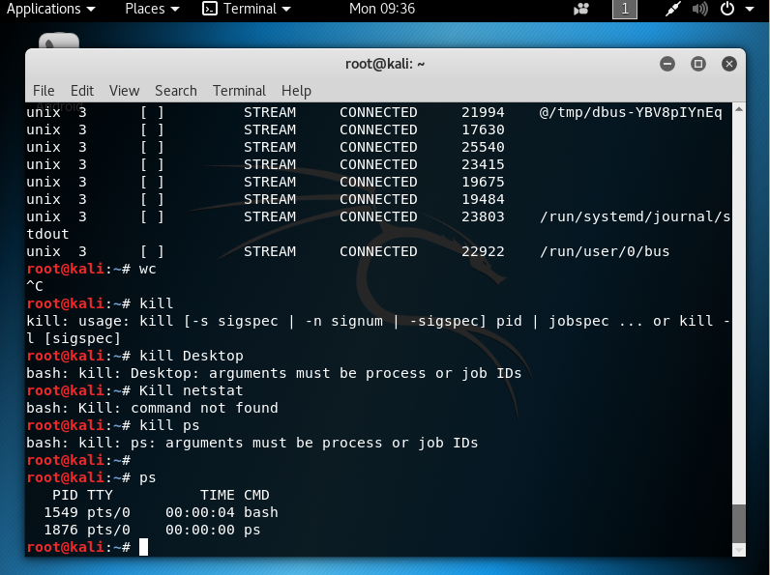

1. top -list process running on the system

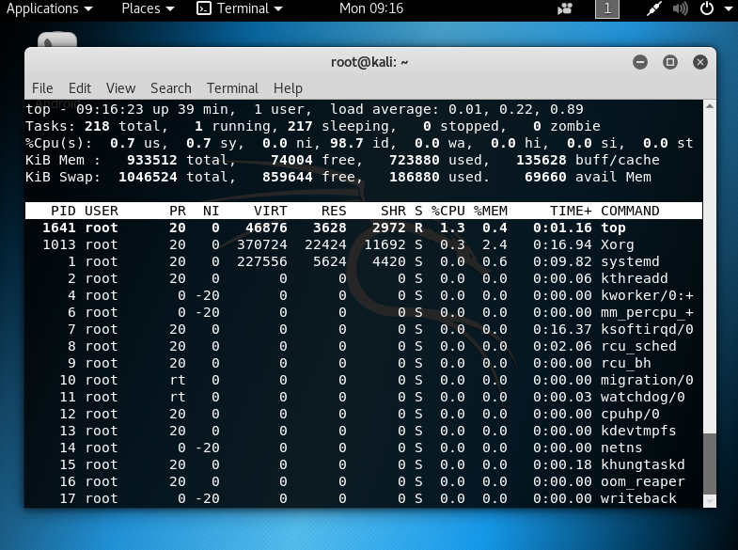

15.uname -print system information

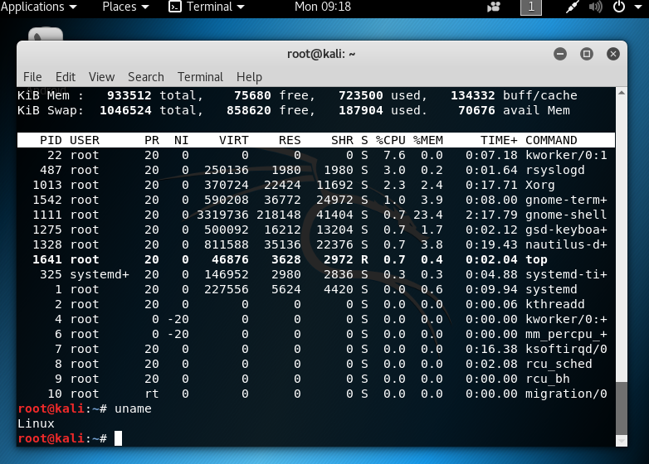

1. uptime - show uptime

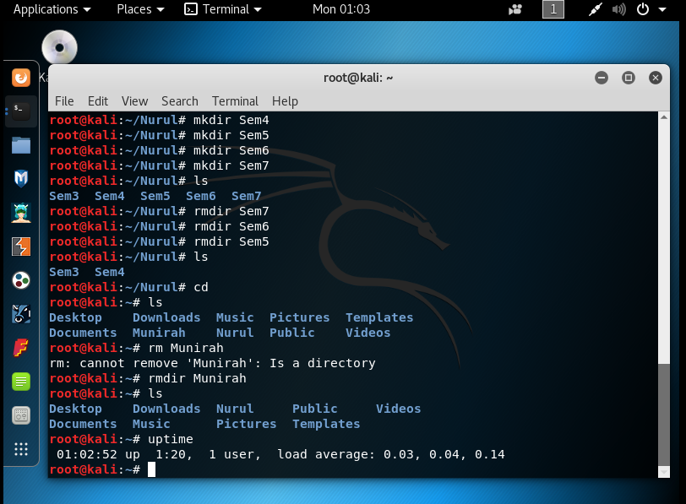

1. ping - test a network connection

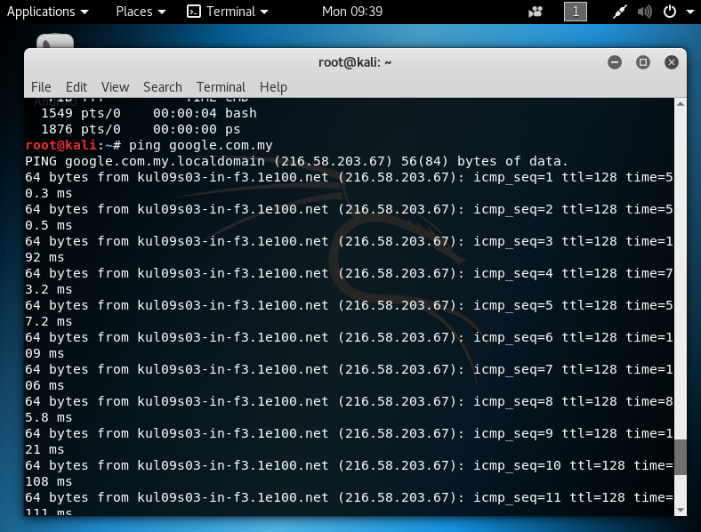

1. netstat -networking information

